Discussion topics for SO meeting.
19-20th August 2004

Aim of the discussion topics 2
Style convention: 2
Polycistronic genes. 2
Rethink of what it means to be a transcript. 4
Pseudogenes 5
Variation/mutation!!! 8
Rendering/visualization of sequence using SO. 8
GO and SO using the same terms: 8
How does gff3 comply with SO? 9
What about similarity? 9
Where are we going with properties? 10
What relationships in SO are necessary? 10

Aim of the discussion topics
The aim of these topics is to describe a SO issue, and provoke discussion which will hopefully lead to lots of ideas and solutions. The topics are not in any particular order.

Style convention:
In this document, terms from SO are written in italics, whereas relationships are bolded.

Polycistronic genes.
The problem:
Polycistronic transcripts cause conflict in the current model.

Several genes that are within the same operon, same promoter and are transcribed together producing one mRNA. This conflicts with our transcript part_of gene model.

Example, the Lac operon has three enzymes LacZ, lacY and LacA transcribed together,
This is the opposite of the way the relationships are modeled in SO.
How to accommodate this in the model

Terms in SO at the moment:
Operon
mRNA
polycistronic_mRNA
polycistronic_primary_transcript
polycistronic_gene

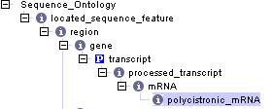
This causes a conflict because the polycistronic transcript is part of a gene by transitivity, but in reality, the transcript is not part of a gene, but belongs to several genes.

Genbank/Embl – feature operon – region containing polycistronic transcript containing genes that encode enzymes that are in the same metabolic pathway and regulatory sequences.

Possible solution?
Polycistronic_mRNA part of Operon
Gene part of Operon.

The gene has no transcript. It is the Operon that has the transcript. The gene is not part of the mRNA, its ORF is but not the whole gene.

Consequence: It must not be necessary for a gene to have a transcript.

LacZ gene
LacZ
LacY
LacA
genomic
P
Polycistronic_mRNA
LacZ
ORF

LacY
ORF
LacZ
ORF

Does this resolve other types of polycistronic transcripts such as ribosomal RNA?

But this does not solve the problem of ‘what is a polycistronic_mrna?’ If it is_a mRNA, then there are still conflicts. Do we need a radical rethink of what is to be a transcript?

Rethink of what it means to be a transcript.
Problems with transcript:
- Assumption that a transcript is part of a gene is flawed because of polycistronic transcripts. What is a polycistronic_mRNA?
- There are issues related to ‘time’ that cause problems in the transitivity of the parts of transcripts. There is a time difference between primary and processed transcripts, that cannot be captured by either isa or part_of relationships. For example, in the current model, cap is part_of mRNA is part_of processed_transcript is part_of transcript is part_of gene. BUT cap is not part of a gene, it is added to the processed_transcript. We could not isolate the cap part of a gene because it does not exist. This is true for polyA_tail. Another example of this is trans-splicing, where a spliced leader is added to the 5’ end of transcripts (See C. elegans). The spliced leader is not part of the genomic sequence of the gene.

To try to resolve time issues, we have started to use the relationship derived_from. We need to define this relationship and understand its powers of transitivity.
if A is part_of B and B is part_of C, then A must be part_of C.
if A is part_of B and B is derived_from C, then is A part of C?

Things that are right about the model.
Exon part_of transcript. This is true because we can locate the exon on both the primary and processed transcripts.
Intron part_of primary transcript.
Primary_transcript part_of gene

Transcript is like an abstract class.

This is a possible solution:
region
gene
transcript
Processed_transcript
intron
exon
mRNA
ncRNA
Primary_transcript
Polycistronic_transcript ??
CDS
isa
part_of
derived_from

What are the consequences of this model?
Exon part_of transcript, primary_transcript isa transcript, exon part_of primary_transcript
mRNA, ncRNA are not part of primary_transcript
polycistronic_transcript isa transcript.
What happens to CDS? It is no longer directly part_of a gene.

Pseudogenes

Definition: A sequence that closely resembles a known functional gene, at another locus within a genome, that is non-functional as a consequence of (usually several) mutations that prevent either its transcription or translation (or both). In general, pseudogenes result from either reverse transcription of a transcript of their "normal" paralog (SO:0000043) (in which case the pseudogene typically lacks introns and includes a poly(A) tail) or from recombination (SO:0000044) (in which case the pseudogene is typically a tandem duplication of its "normal" paralog). On occasion a pseudogene is functional as a consequence being "captured" by a non-paralogous gene, it is then known as a "captured_pseudogene" (SO:0100042).

Position in Ontology.
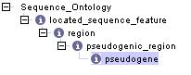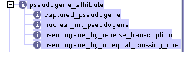

Issues.
Problems.
Mutations causing premature stop. Is this a gene with a mutation or a pseudogene? How do you prove something is a pseudogene. There are lots of permutations to test. Should a pseudogene have to same parts as a gene can have? We may want to annotate its exons. Is a pseudogene a gene? What other types of psuedogenic thing are there?

Genbank/Embl – pseudo is an optional qualifier.
Pseudogene.org – pseudogenes are sequences of genomic DNA with such similarity to normal genes that they are regarded as non-functional copies or close relatives of genes.

If we want to iterate over the real exons of a genome however, we will want to exclude the pseudo-exons.

Where do pseudogenes come from? – duplication and retrotransposition.
Do we need to diversify and have duplicated_pseudogene and processed_pseudogene?
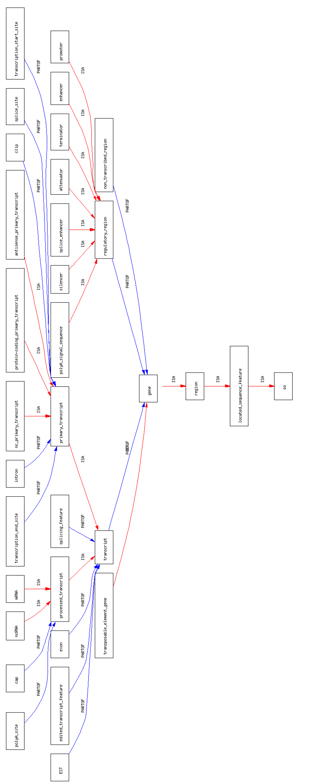
Some of the key locatable_sequence_features surrounding gene

Variation/mutation!!!
Harvard curators find sequence_variant misleading and want to call it mutation.
Discuss.

How do we relate mutations to locatable sequence features?

Do we need to expand this aspect?

Rendering/visualization of sequence using SO.
The problem:
Different groups have different ideas of what is meant by a gene model. Upenn/cbil people describe a gene model as all of the exons in all of the transcripts of a gene. The Apollo people imply a gene model from the transcripts that can be added to a gene as a whole. This debate arose when these two groups started to think about using SO for the types and relationships in their software.

Promoter causes problems for these groups. They agree that the relationship between a promoter and a transcript is different from between an exon and a transcript. This is important because in visualizing a gene model you may want to draw a line thru the parts of a transcript.

In SO the promoters and regulatory regions are part_of gene. As Sima pointed out, some transcripts within the same gene have different promoters, so there needs to be a relationship between promoter and transcript. This relationship is not part_of for logical reasons. We could not isolate the promoter part from a transcript.
Mark Gibson suggested “associated_with”

This makes sense from a biological point of view. From an ontological point of view, what does associated_with mean? Is it transitive? Has it been used in any of the other OBO’s? Will this cause problems?

Genbank/Embl do not specify relationships so they are not much help. They do give these definitions:
Promoter – region on a DNA molecules involved in RNA polymerase binding to initiate transcription.
Gene – region of biological interest identified as a gene and for which a name has been assigned. Comment: it is meant to represent a region where the gene is located.

GO and SO using the same terms:
Does it matter? They both have different ids….
Chromosome
Kinetoplast
Plastid
Leucoplast
Proplastid
Cyanelle
Apicoplast

Can we reference GO from SO? Make a cross product.

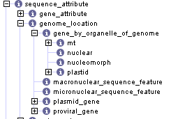

This would require that we import the cellular location aspect of GO.
SO:Mitochondrial_genome
SO:Genome_location
GO:mitochondria
isa
part_of

How does gff3 comply with SO?
How does it handle relationships? Can we force ‘SO-compliant GFF3’ to use the OBO relationships. This would be in column 9.
Can GFF3 use other ontologies as well as SO. How does that work?

What about similarity?
Do we need terms to describe homology, orthology, paralogy etc
Syntenic region,
Should they be properties of match? They always refer to another bit of sequence somewhere. Does this mean we are defining relationships rather than types?

%region
%homologous_region
%paralogous_region
%orthologous_region

In this example, we are left with the question ‘homologous with what?’

We could define the following relationships:
Types
%Has_similarity_to
%Homologous_with/
%Paralogous_with
%Orthologous_with

Currently in SO we have terms to describe the results of sequence similarity algorithms. See ‘match’. This idea is only half born however as we need to express what the match is with. Relationships of this type allow us to express this. These relationships should apply to any region.

Where are we going with properties?
How are properties different from relationships?
The sequence_attribute aspect of SO defines the attributes of the locatable_sequence_features.

What relationships in SO are necessary?
DAG-Edit allows us to specify if a relationship and/or its inverse is necessary. This allows us to reason more thoroughly over sequence marked up with SO. Defining whether a relationship must or may be true is a minefield. For example, we may think that it is necessary for a gene to has_part a transcript. This seems sensible; we reject annotations where there is no transcript. But then we lose all of the polycistronic genes and all of the annotations that have specified CDS but not transcript. Are there any relationships in SO that absolutely must be?

